**Assignment: 3(b)**

**Priyaben Pareshbhai Patel (8165235)**

**Technology Infrastructure Principles(INFO8220)**

**Steven Sutherland**

**February 14, 2018**

**Sigh Impaired**

**Android- Magnification Gestures**

* It enables screen magnification.
* To use this feature, go to setting->Accessibility->Magnification gestures turn on it.
* Once the magnification gesture is enabled one still need to triple-tap the screen with single finger if he wants to zoom the screen. Increasing and decreasing the viewable screen size is done by pinching the thumb and finger together and spreading them apart.

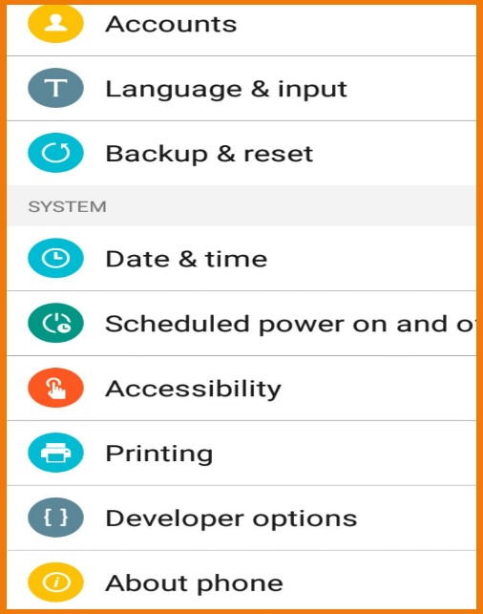

**iPhone- Color Inversion**

* It transposes colors
* To use this feature, go to settings->General->Accessibility->Invert color
* It changes the screen display from black text and white background to white text on black background.

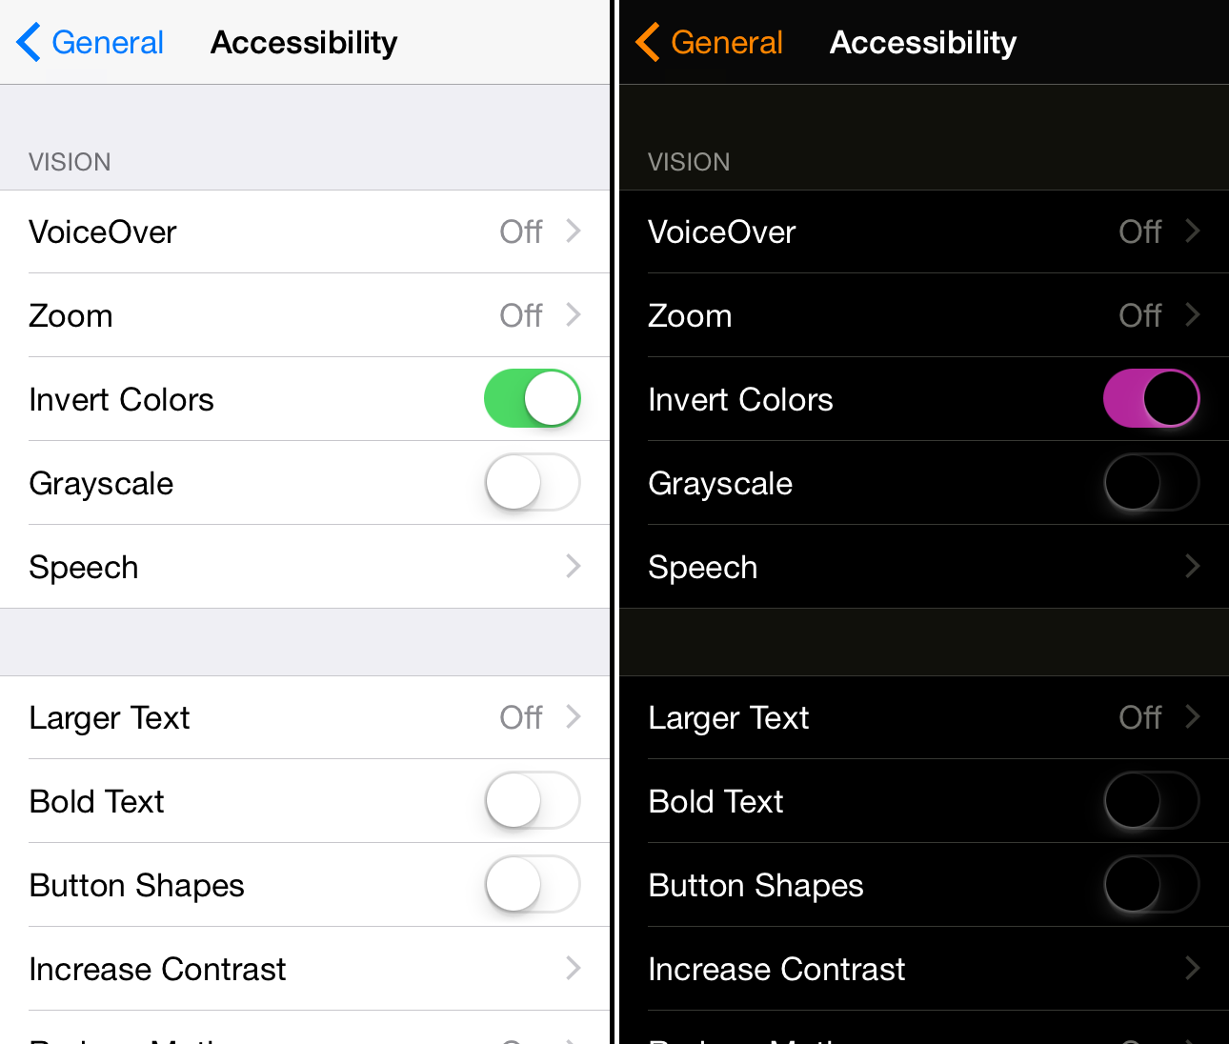

**Hearing Impaired**

**Android- Mono Audio**

* It combines channels when playing audio
* To use this feature, go to setting-> Accessibility->Mono audio turn on it
* Instead of both headphones audio will come out from only one headphone for better hearing.

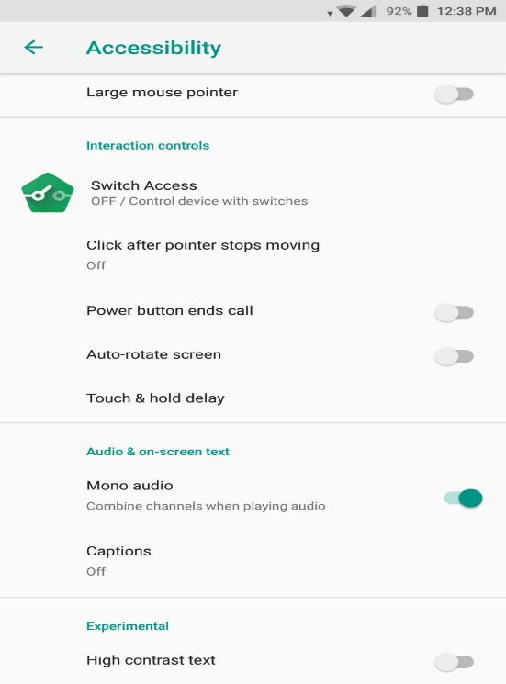

**iPhone- LED Flash for Alert**

* It flashes LED for visible cue for incoming notification.
* Launch settings->General->Accessibility->switch Flash LED for Alert or switch Flash on silent
* When any notification comes the LED flashes so that person can know about notification if he does not hear the notification sound.

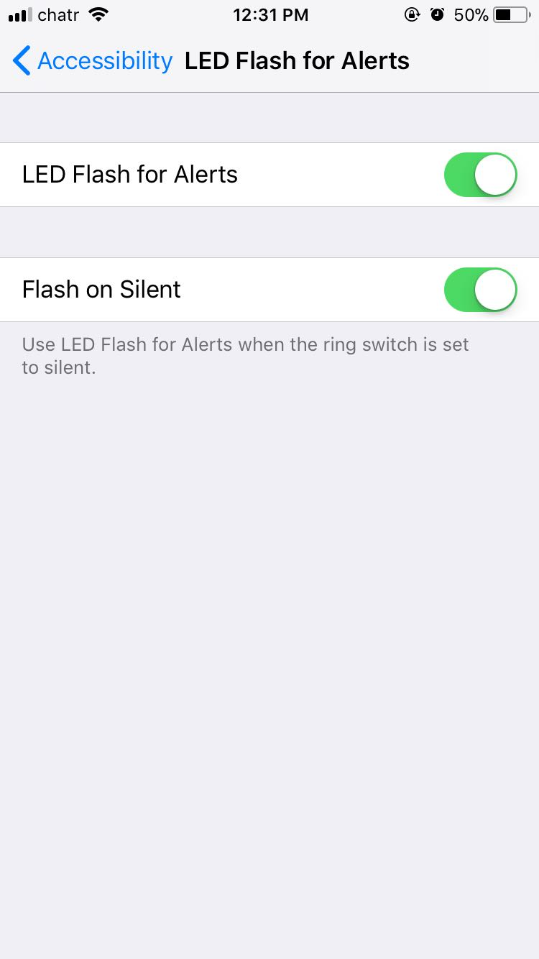

**Physically Impaired**

**Android- Switch Access**

* It allows the physically impaired person to interact with android through external switch, keyboard or button instead of touch screen.
* To access this feature, go to setting->
* Switch access scans the screen items, user can select the item which he wants to operates through external switches, keyboard or built-in buttons on android device such as volume up and volume down button. External switches connect to android device via USB or Bluetooth.

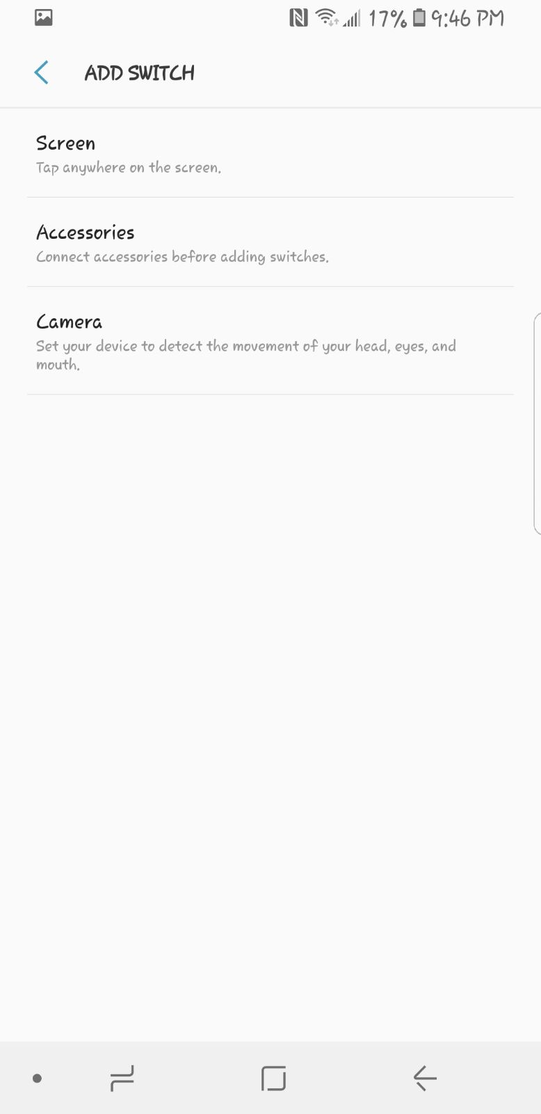 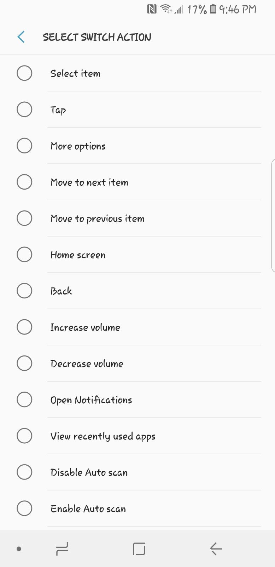

**iPhone- Assistive Touch**

* It allows the user to use iPhone if one has difficulty to touch the screen or if require an adaptive accessory.
* To turn on this feature go to settings->General->Accessibility->Assistive Touch
* After turning on assistive touch user can customize the menu and set custom actions as per requirements or can create new gesture also. Using this feature enabled, user will be able to perform actions like pinching to zoom or 3D touch with just a tap.

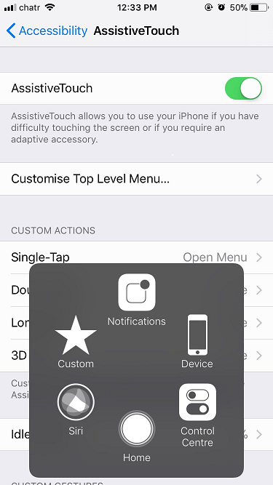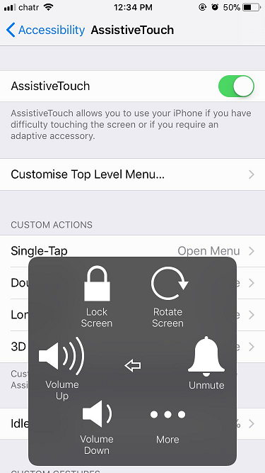 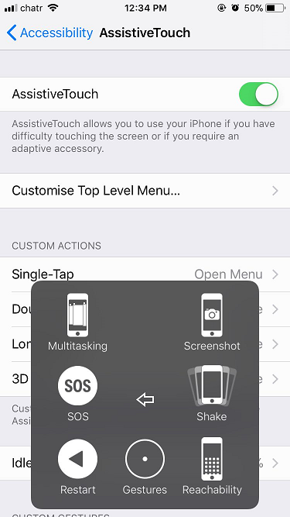

**App for Sight impaired- Android**

**Large Launcher**

* This app replaces the view of phone with large icons and font so that visually impaired people can easily use their phone.
* It provides color-coded icons which helps to easily distinguish between different items. This app contains easy to touch large buttons, big phone dialer and message text.

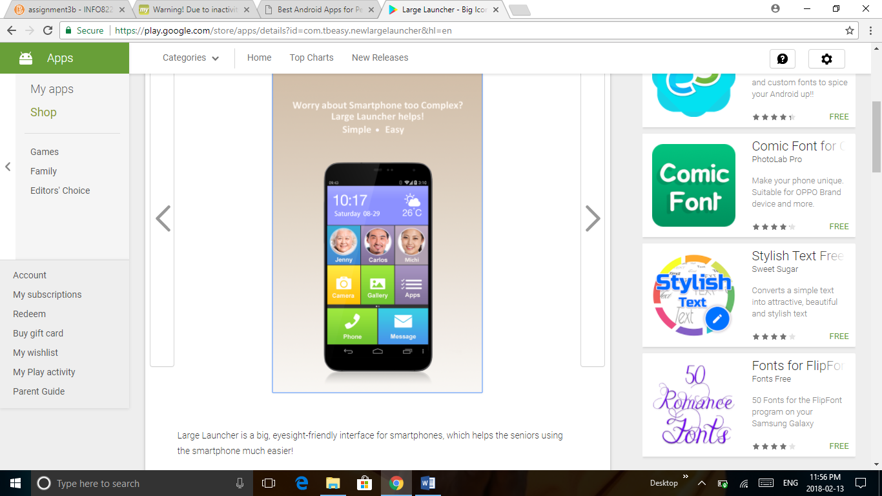 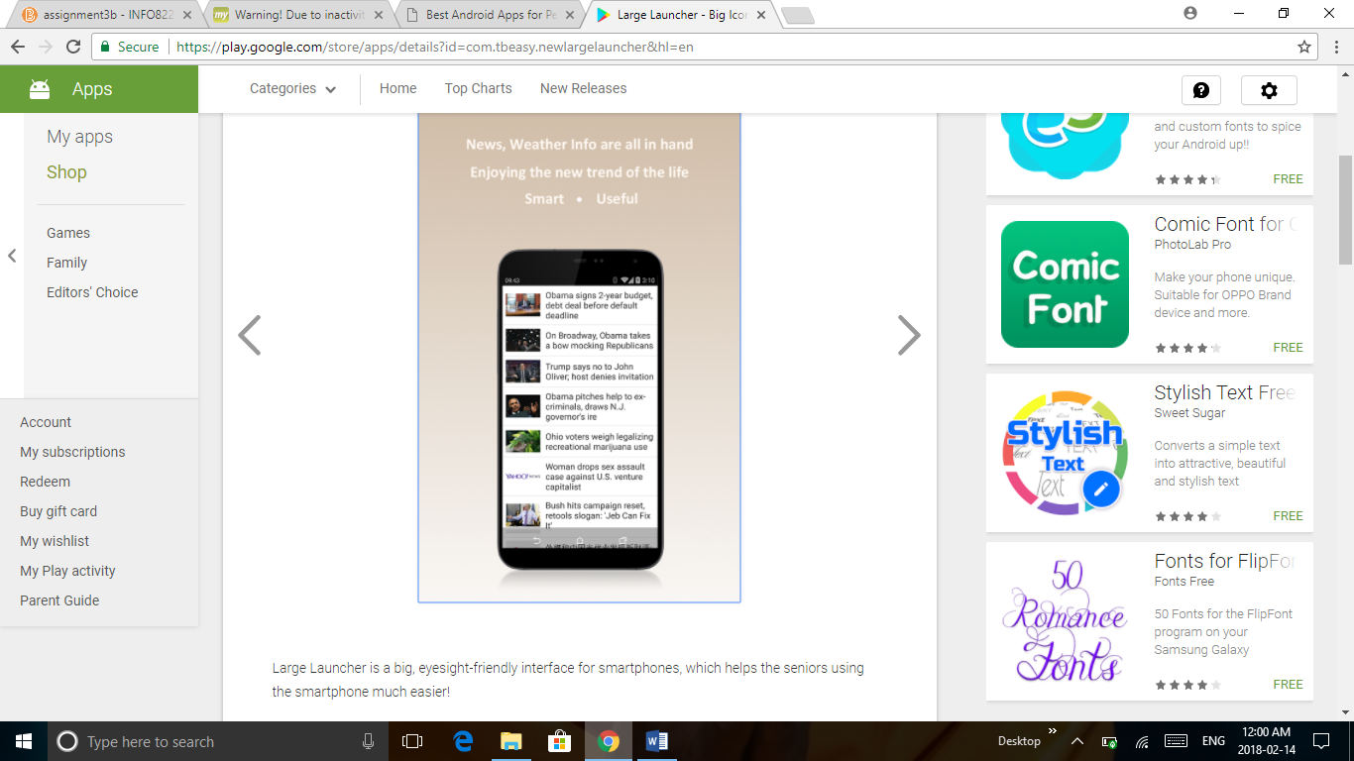

**App for Sight impaired – iPhone**

**Aipoly Vision**

* It is a color and object recognizer that helps the visually impaired person to know their surroundings.
* User have to keep phone in front of the thing which he wants to identify and have to press the toggle button it will turn on the artificial intelligence. It can also recognize colors.
* User can also add description of object to help other users. It will automatically turn on the torch if it detects darkness and will automatically turn off the torch when light is switched on.

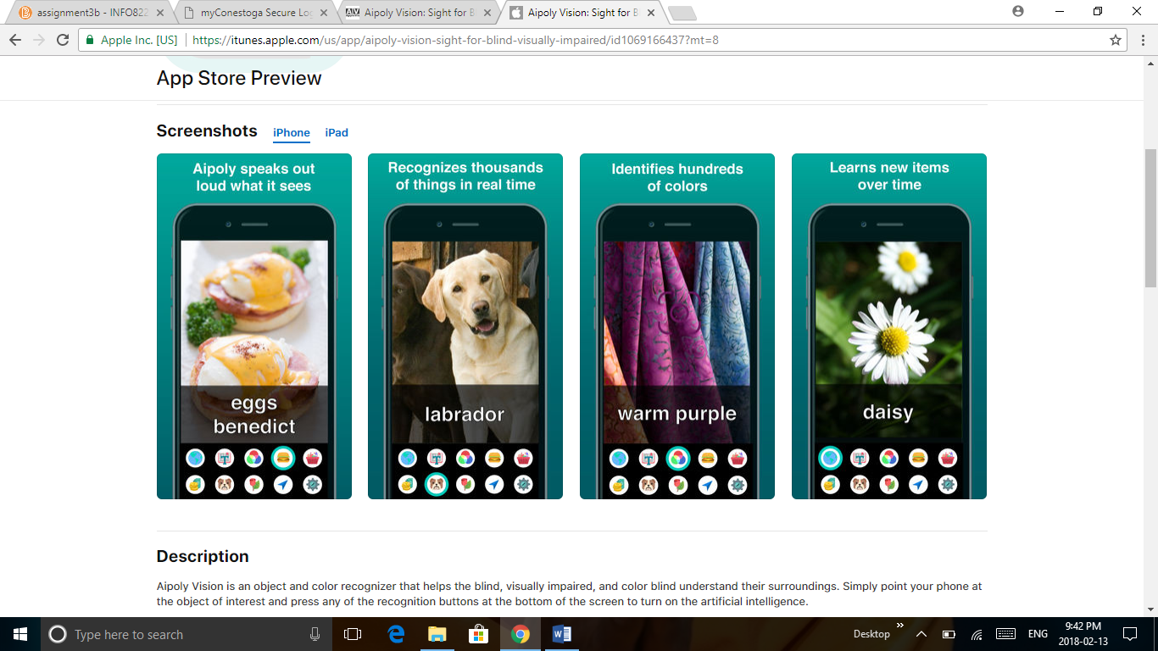 

**App for Hearing impaired- Android**

**Text Hear**

* It is very helpful app for hearing impaired people. Text Hear is voice recognition app. It helps to assist conversations by converting voice to text.
* User have to click the mic in order to convert the speech into text. After voice recognizing it will display the text with large font size on the screen.
* It automatically adds spacing and punctuation to text. It is multilingual, user can choose language as per requirements.

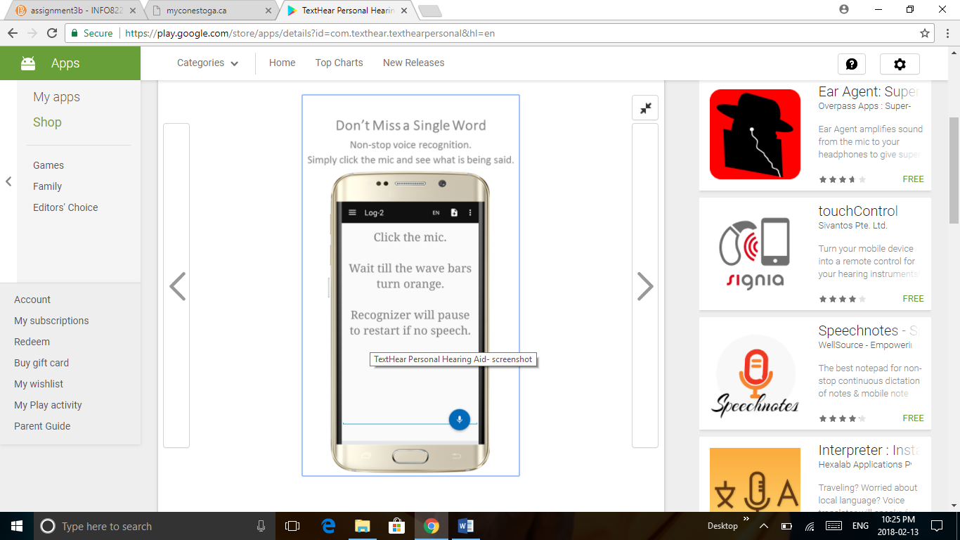 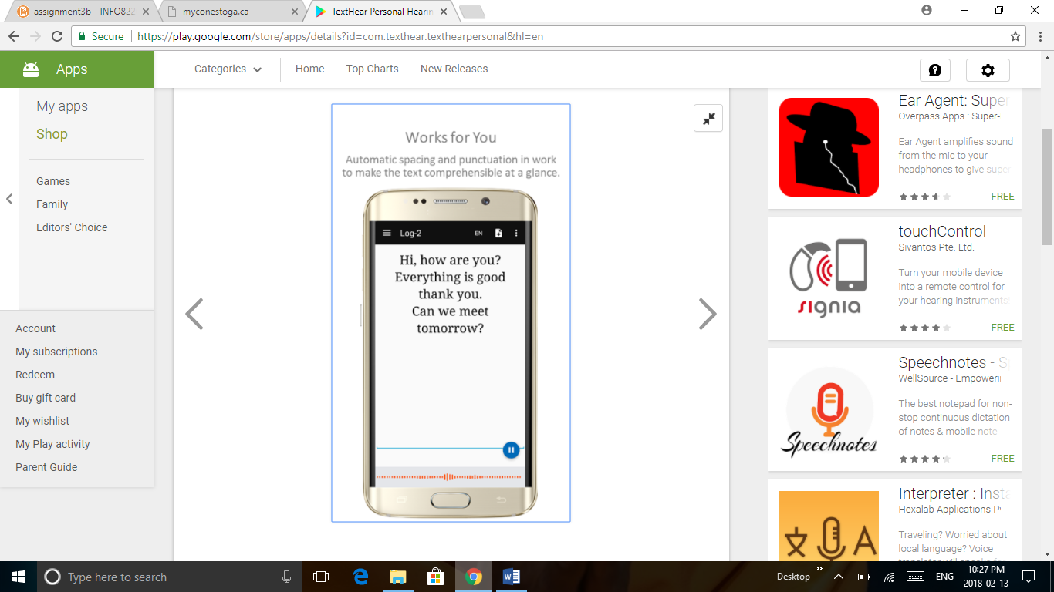

**App for Hearing impaired – iPhone**

**Super Hearing Aid – audio enhancer**

* It converts the iPhone into hearing aid.
* This app amplifies any kind of audio, removes background noice and provides audio with best clarity. User can tune audio for indoors as well as outdoors. It also provides playback option if any audio is missed.

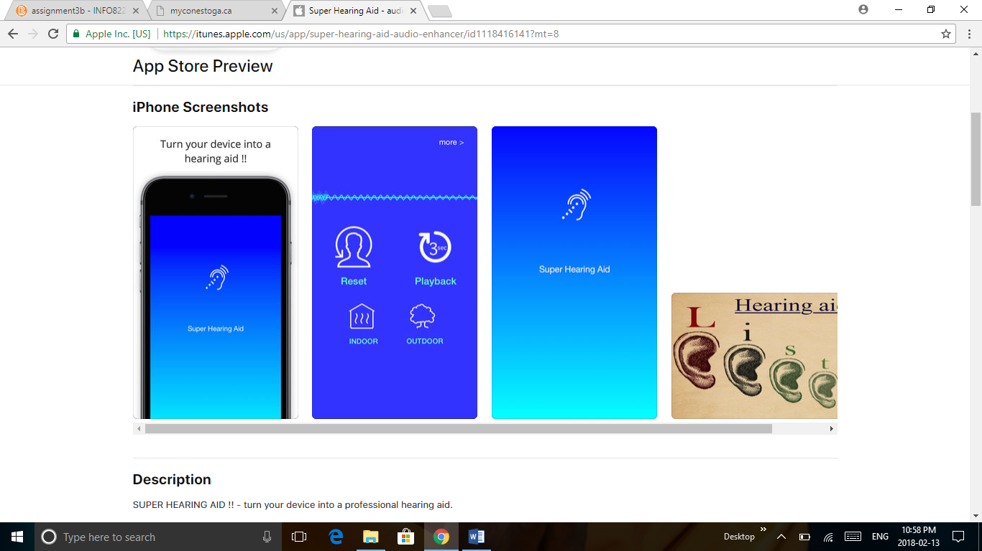 

**App for Physically Impaired – Android**

**It’s Accessible**

* This app helps to find accessible places (mall, bars, hotels, parking, restaurants…) for people who has mobility problems.
* People can share new places that are accessible for physically impaired person. People can also rate the place according to accessibility.

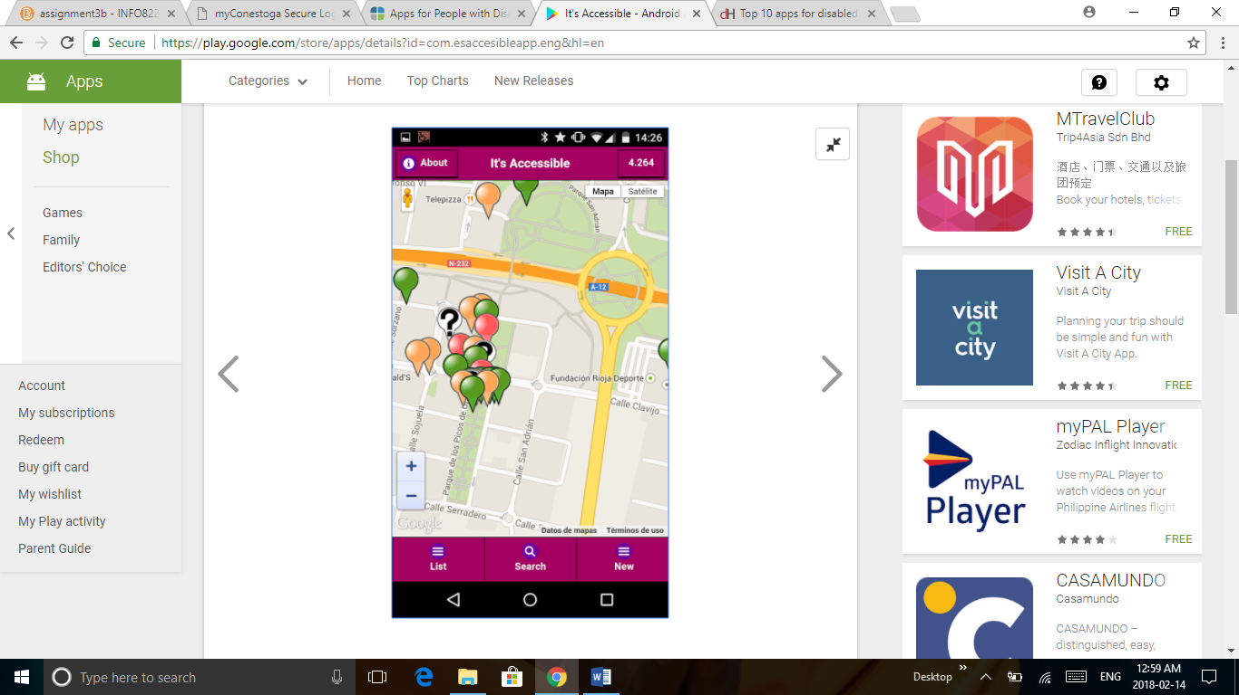 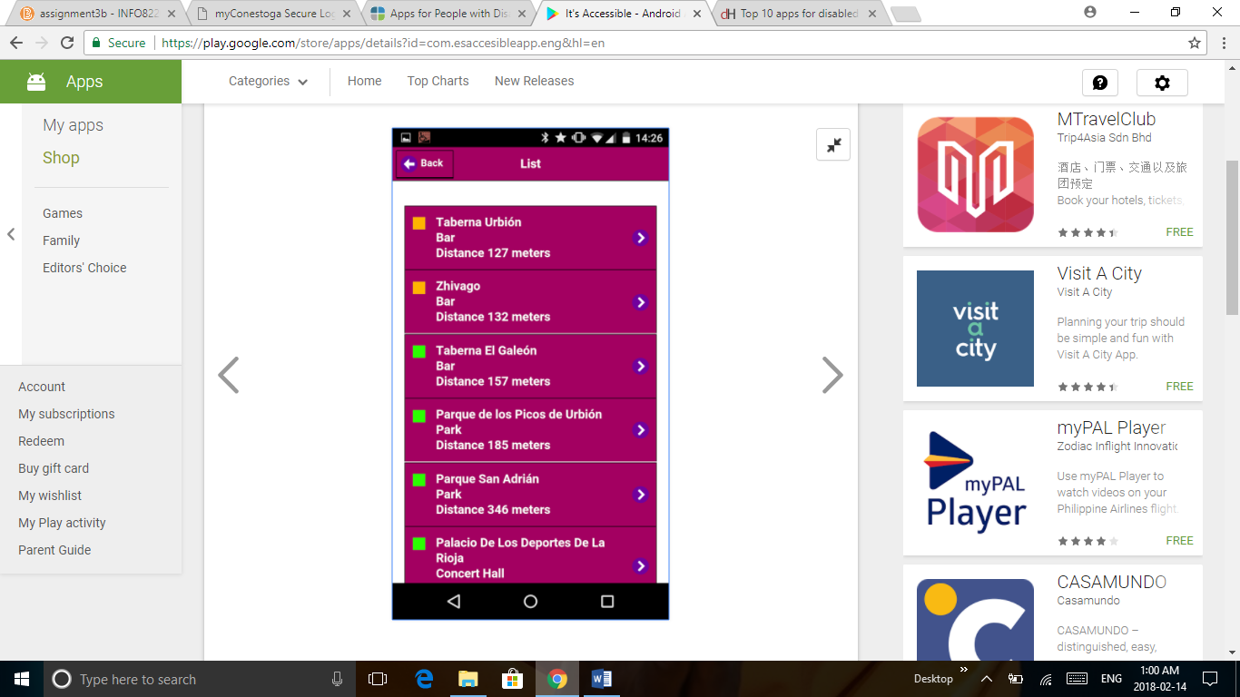 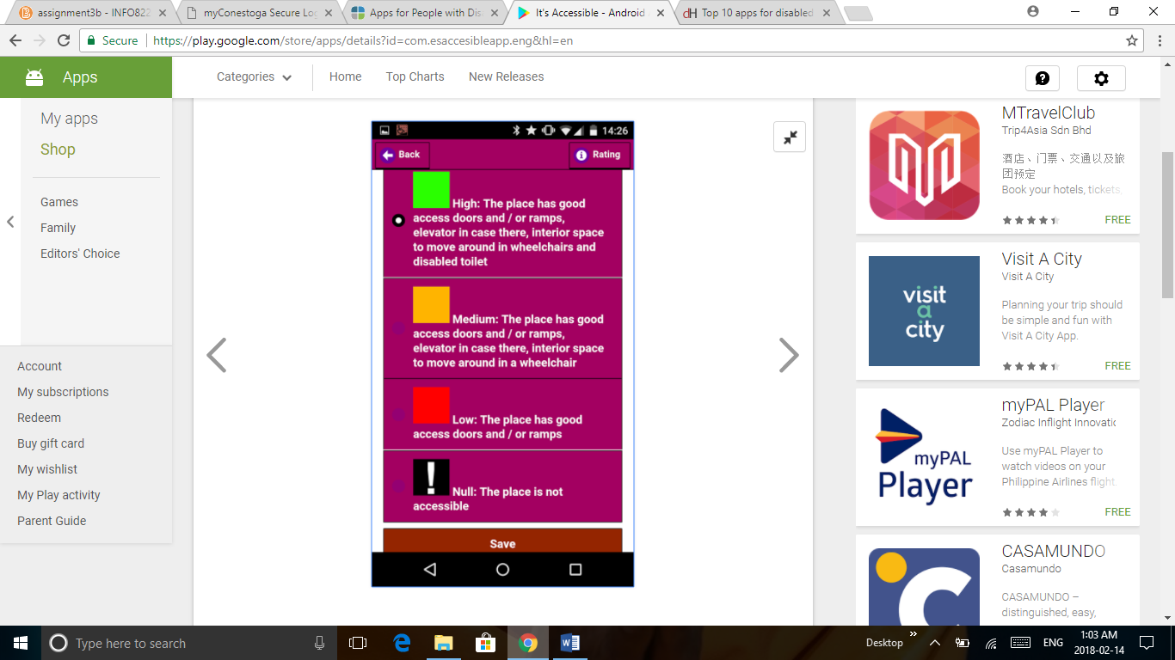

**App for Physically Impaired – iPhone**

**WheelMate**

* This app helps to find clean, accessible toilets and space for parking to people with wheelchair or has any mobility issues.
* User can search nearest accessible place by entering location, can add new places, can rate and comment the place and help the other people.

